Draw TRNFlow's ventilation circuit in Graphviz

# Ventilation circuit of TRNFlow

Looking at the setting screen of TRNFlow, is it not painful to imagine a ventilation circuit? I am painful.

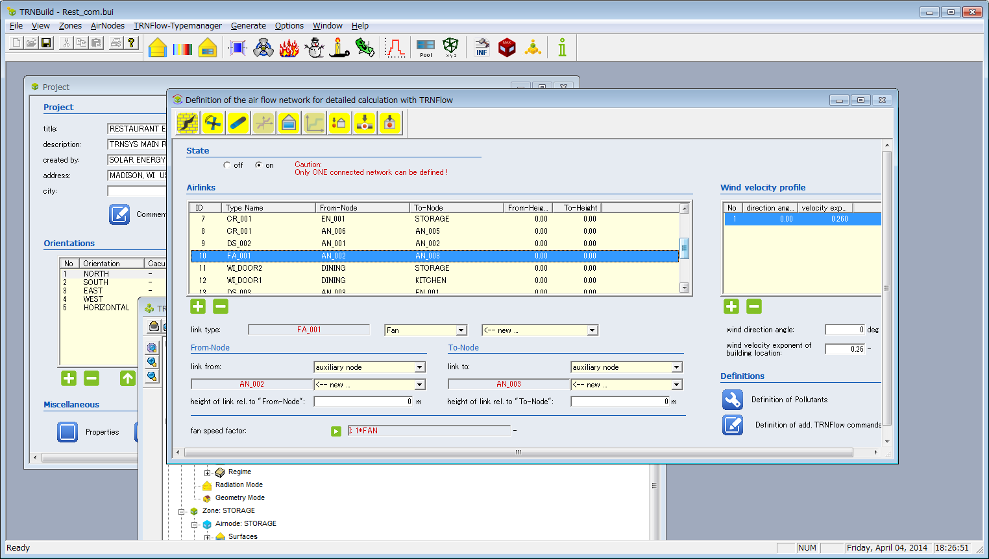

Is not it painful to imagine a ventilation circuit from this list display? What?

When I thought that there would be no way to check it more visually, I noticed that Graphviz (http://www.graphviz.org/) could be used. This tool draws a diagram automatically from a simple description.

# I thought of it immediately. . .

Even if you say that this tool, simple description is OK, you can not display TRNFlow data as it is, so a bit of ingenuity is required.

Or I tried writing a program "AirlinkToDot" which processes the file of Bui (*. B 17) and writes it to Graphviz format.

The mechanism is easy and comparable, and there is a part that defines the ventilation circuit when looking at the contents of Bui.

Below are some extracted items, but the place where FRNODE, TONODE is stated is ZONE or Auxiliary node.

LINK DS_001 : ID= 1 : FRNODE= KITCHEN : TONODE= AN_001

LINK CR_001 : ID= 2 : FRNODE= EN_003 : TONODE= KITCHEN

LINK CR_001 : ID= 3 : FRNODE= EN_004 : TONODE= STORAGE

LINK CR_001 : ID= 4 : FRNODE= EN_004 : TONODE= DINING

LINK CR_001 : ID= 5 : FRNODE= EN_003 : TONODE= DINING

LINK CR_001 : ID= 6 : FRNODE= EN_001 : TONODE= KITCHEN

LINK CR_001 : ID= 7 : FRNODE= EN_001 : TONODE= STORAGE

This part is programmed, it extracts it completely and converts it to the form of Graphviz.

Here is the view of the completed file in Graphviz.

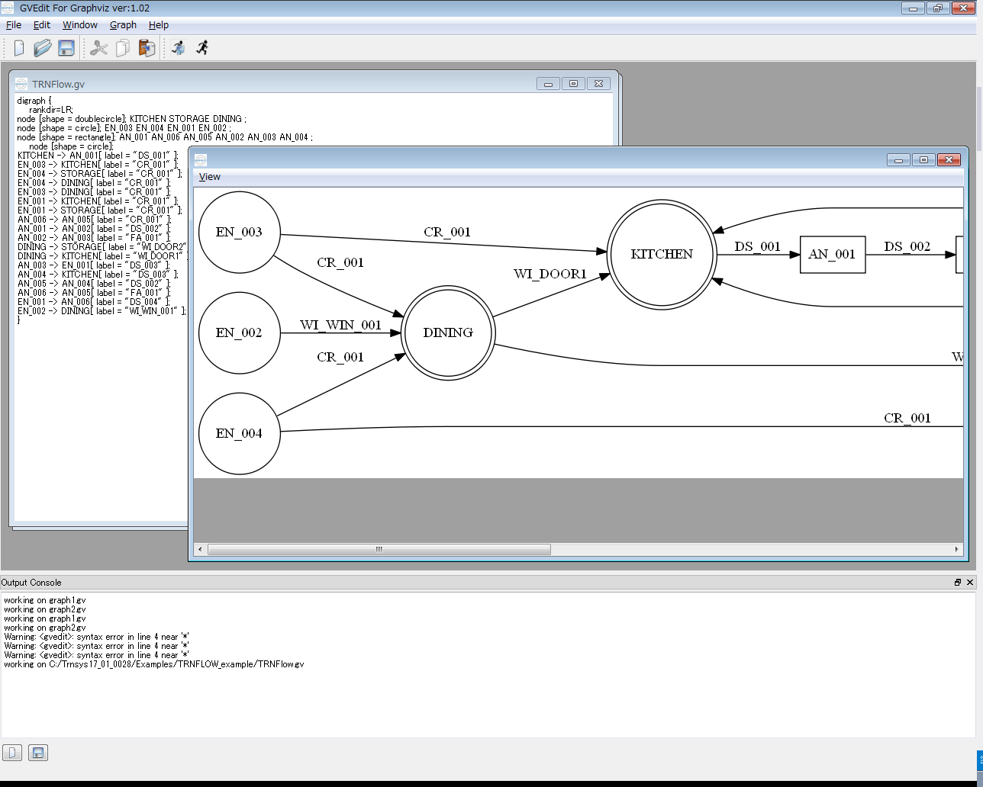

Oh great!!

The connection relation of NODE and the direction of From / To are obvious at a glance!

Although it is the position relation of NODE and it is not done (it is laid out arbitrarily), is it enough for checking?

# How to use the program

* 1. Installation
     1. Install AirlinkToDot

AirlinkToDot installer was added to the repository (https://github.com/TRNSYSJP/TRNSYS.JP).

It is a file called Tools \ AirlinkToDot \ setup.zip.

Since the installer is a general format, after downloading and decompressing it, double-click it, run it, and if you press the button several times, it ends.

* + 1. Installing Graphviz

We will download and install the installer from the official site of Graphviz.

Download (Windows)

http://www.graphviz.org/Download_windows.php

【important】

Please copy all files from 'C: \ Program Files (x86) \ Graphviz 2.38 \ bin' folder to 'C: \ Program Files (x86) \ TRNSYS.JP \ AirlinkToDot \ GraphViz' after installation.

* 1. Startup method

Select [TRNSYS.JP] - [AirlinkToDot] - [AirlinkToDot] from the start menu and start it.

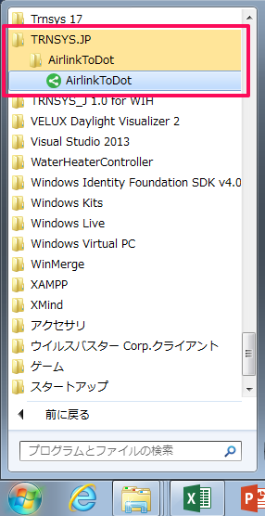

* 1. Convert Bui file to Graphviz format
     1. Basic operation

On the AirlinkToDot screen, click [Load Bui], select the Bui file, or drop the Bui file from the Explorer onto the AirlinkToDot window.

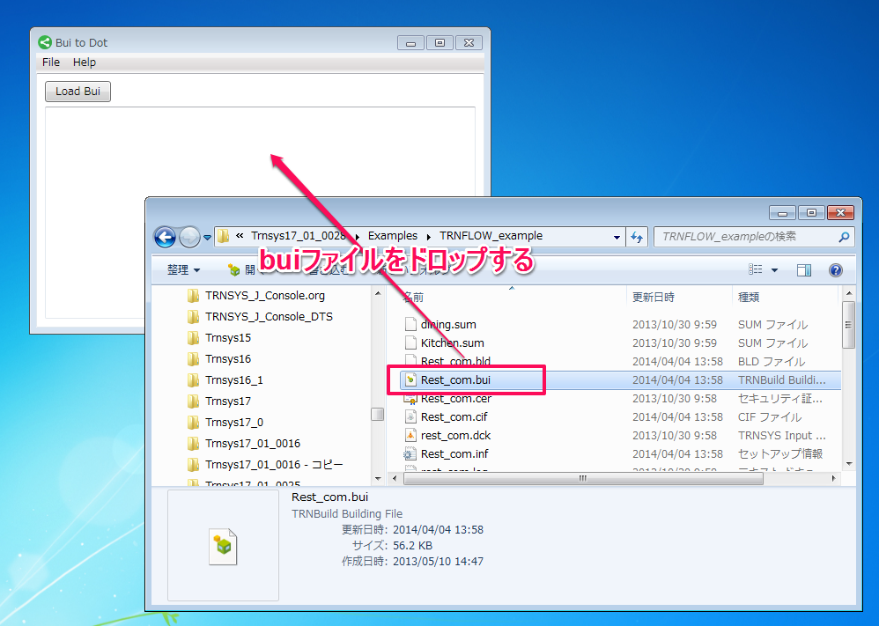

When conversion is completed, data of Graphviz format (*. Gv) is displayed.

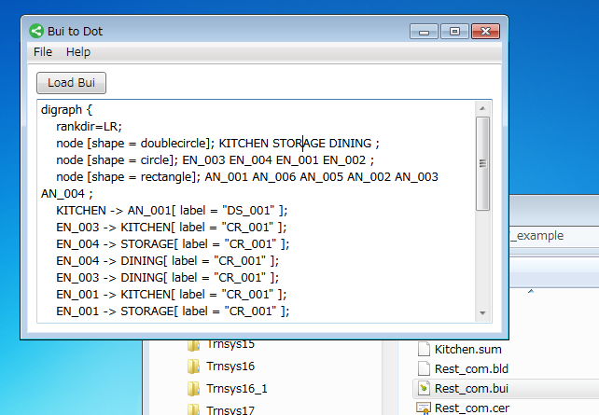

At the same time a diagram is generated in the background and 'Paint' is activated and displayed.

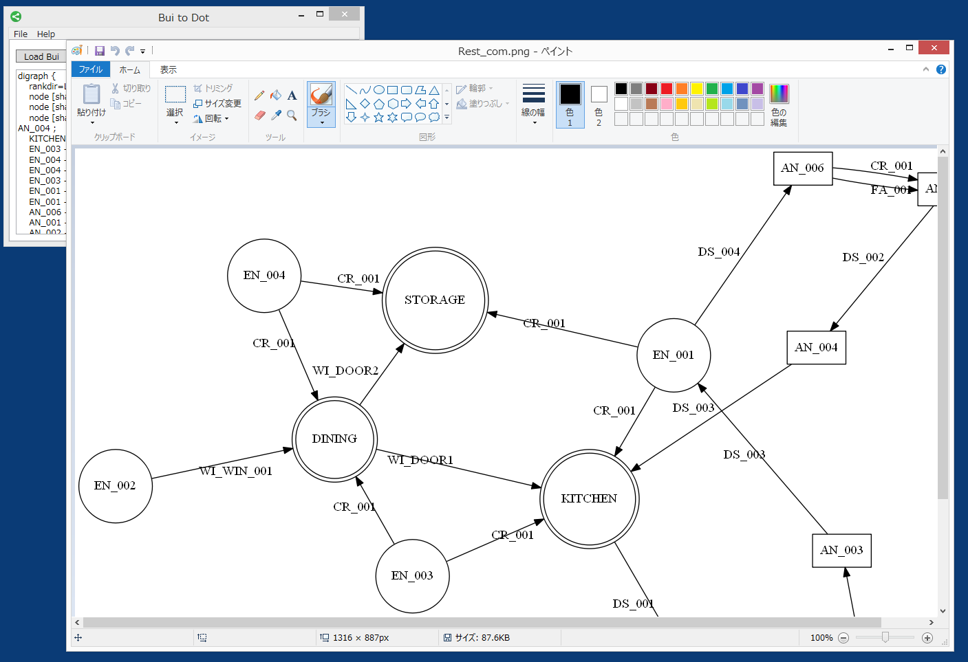

* + 1. Draw a diagram with Graphviz

Start Graphviz, prepare a new file, select the text and drop it.

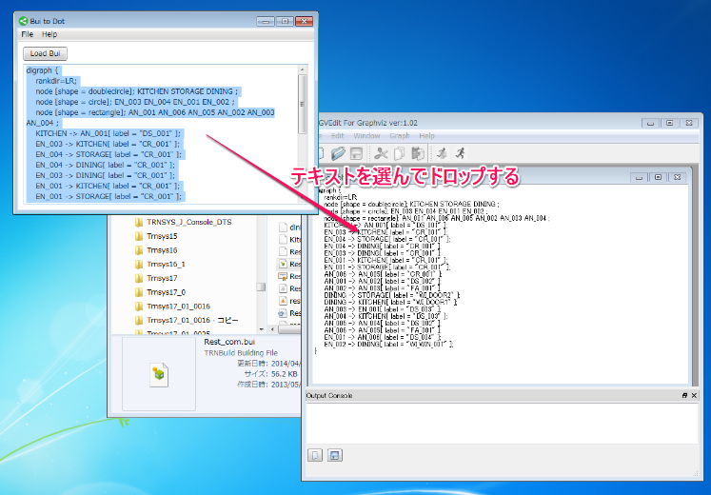

After that, click the [Layout] button and the diagram will be drawn.

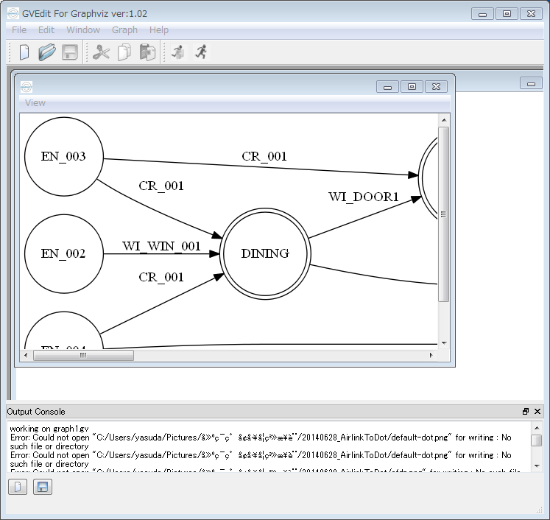

* + 1. About the layout

Well, look at the diagram that was drawn. . .

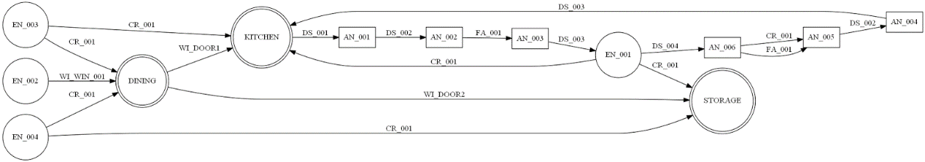

It's oblong and it's hard to see. Since Graphviz has several layouts, I will try to change it.

Click the Settings icon to change the Layout Engine item.

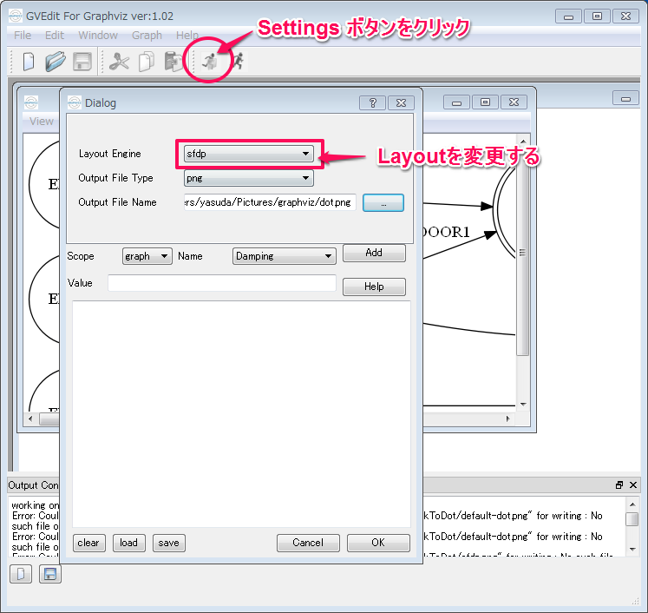

Below is an example of saying sfdp and laying out.

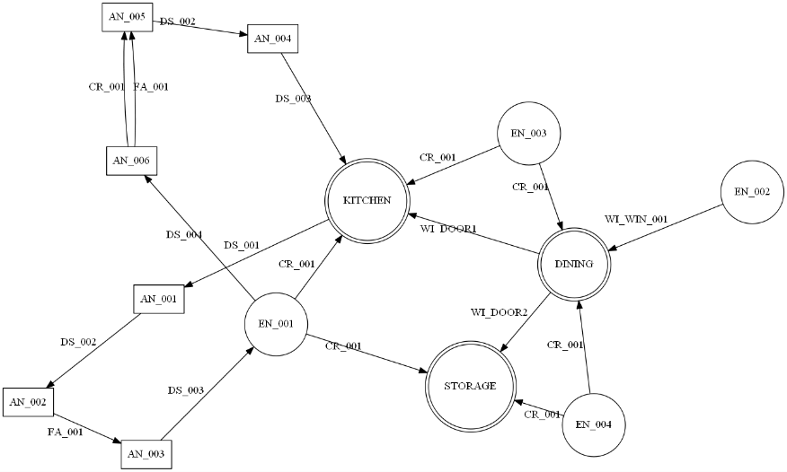

It became quite easy to see.

* + 1. Diagram symbols

図の記号とTRNFlow/Airlinkの対応は次のようになっています。

◎　ZONE

○　External node

□　Auxiliary node

←　Window,Door,Crack,Duct

ということで、TRNFlowの換気回路のデータを図として確認することができるようになりました。